**Project Firestone**

**Jacob Hanshaw Computer Science & Engineering**

**Class: EPD397 Technical Communication Section 014**

**May 1st, 2014**

**Abstract**

The goal of this paper is to outline the planning, development, and implementation of the Project Firestone artificial rock wall solution. The Project Firestone solution uses light up, touch sensitive rock climbing holds controlled through a mobile application to provide a more dynamic and interactive artificial rock wall experience. This results in the ability to expand artificial rock walls from poor imitations of traditional rock climbing to unique experiences in their own right.

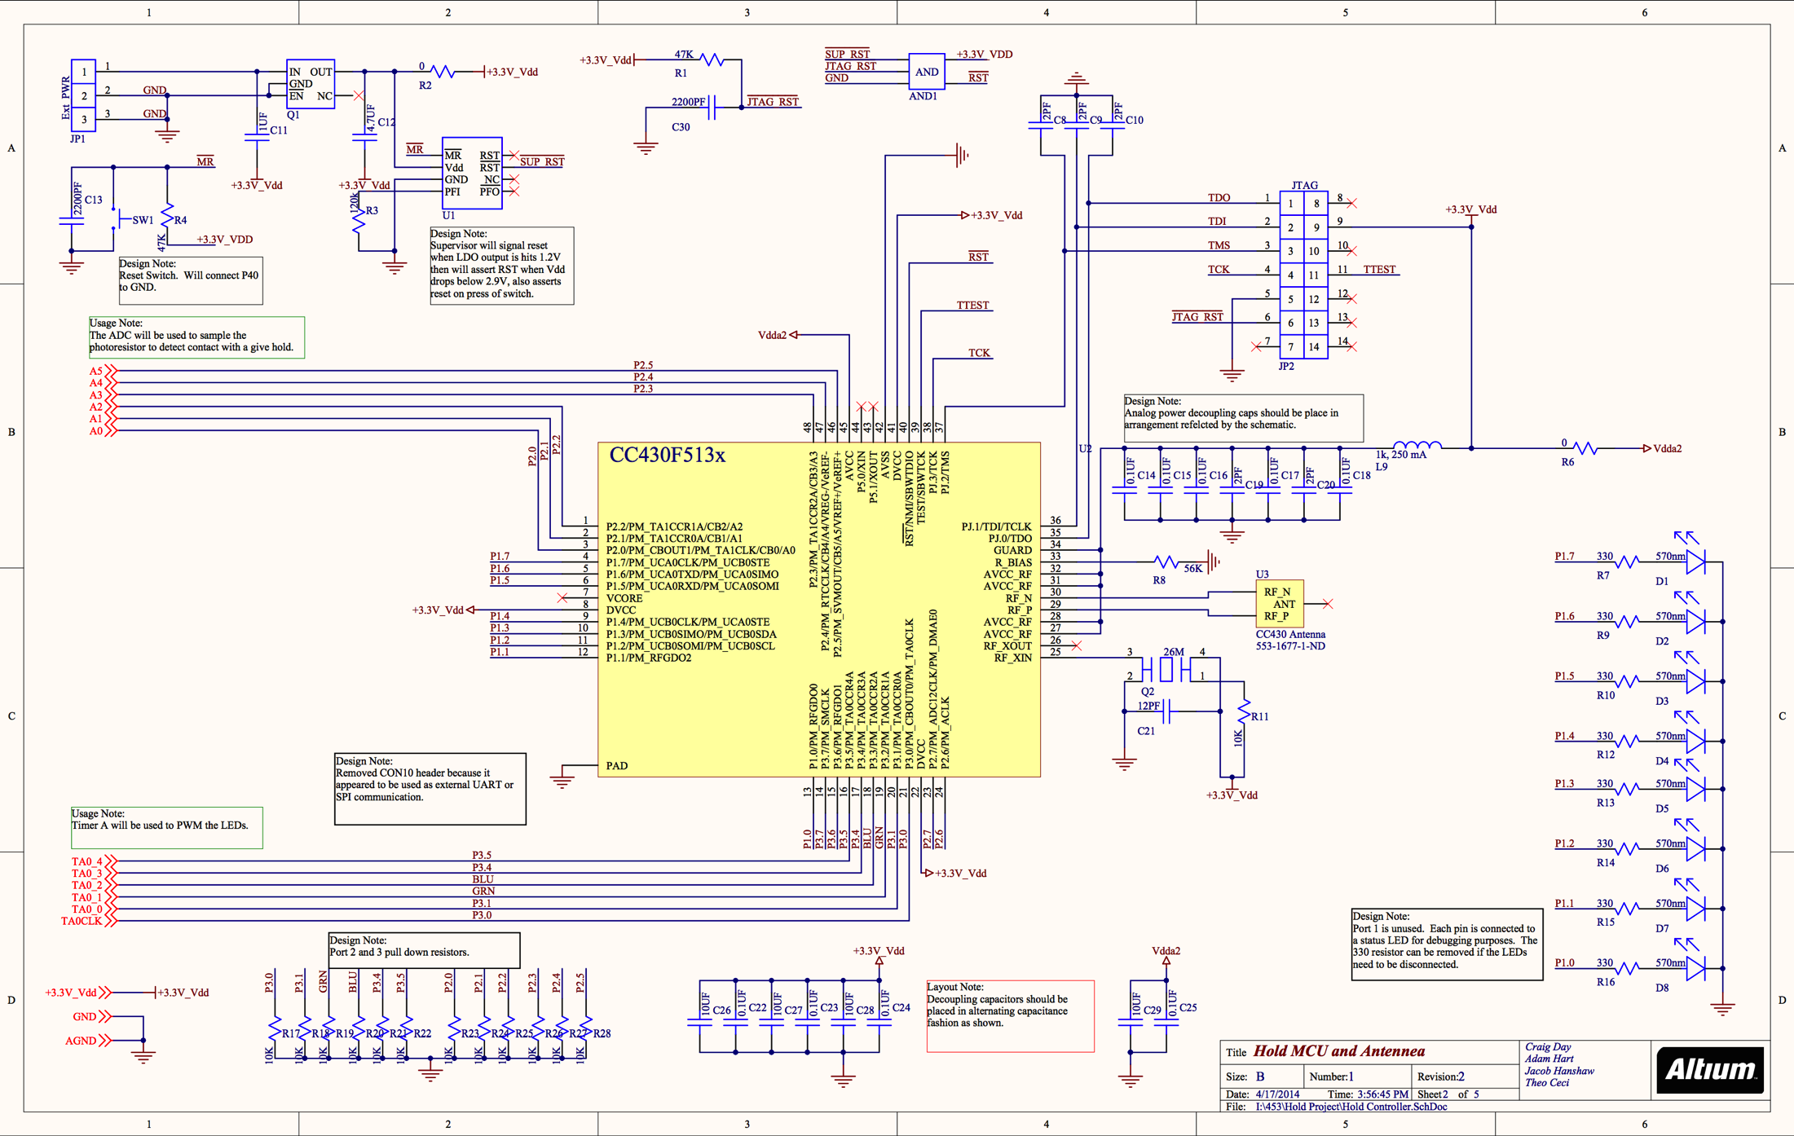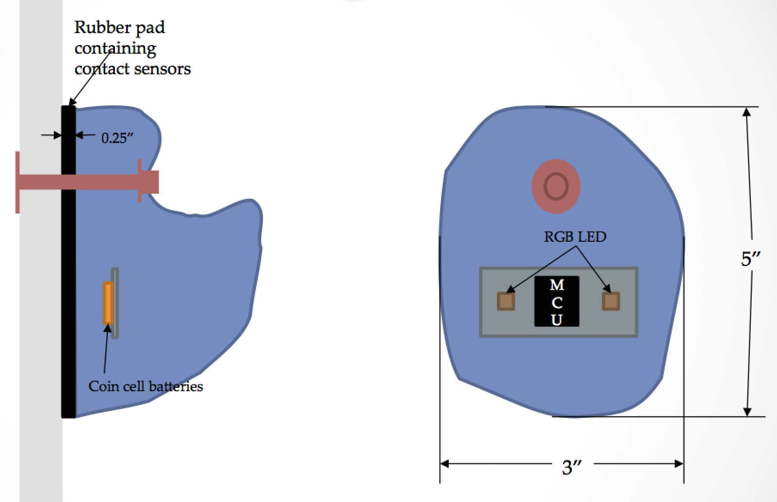**EPD397 Technical Communication Section 014**

**Spring 2014**

**Jacob Hanshaw**

**Project Firestone**

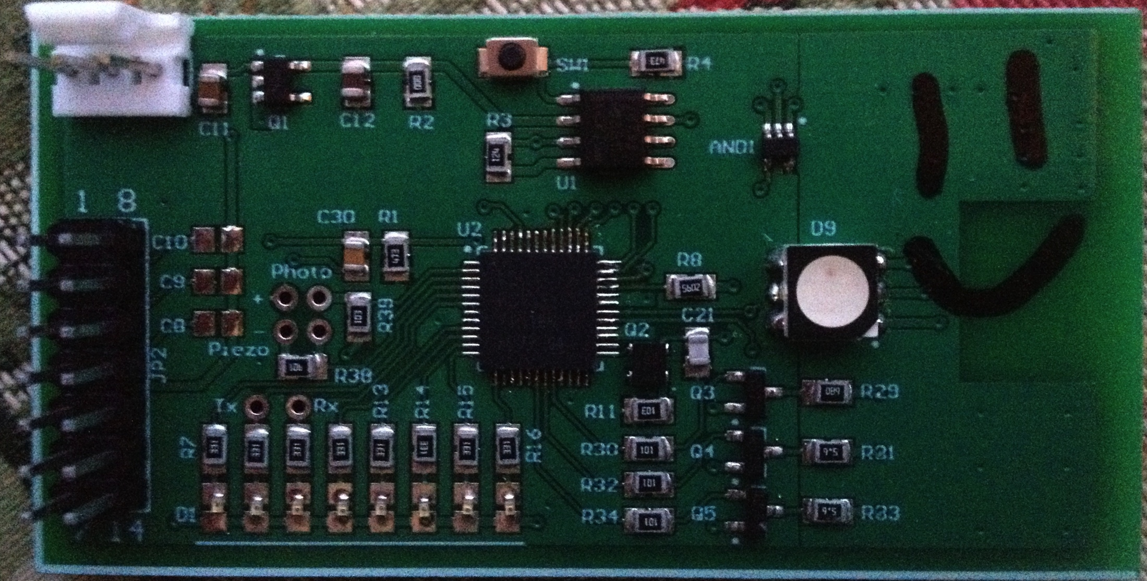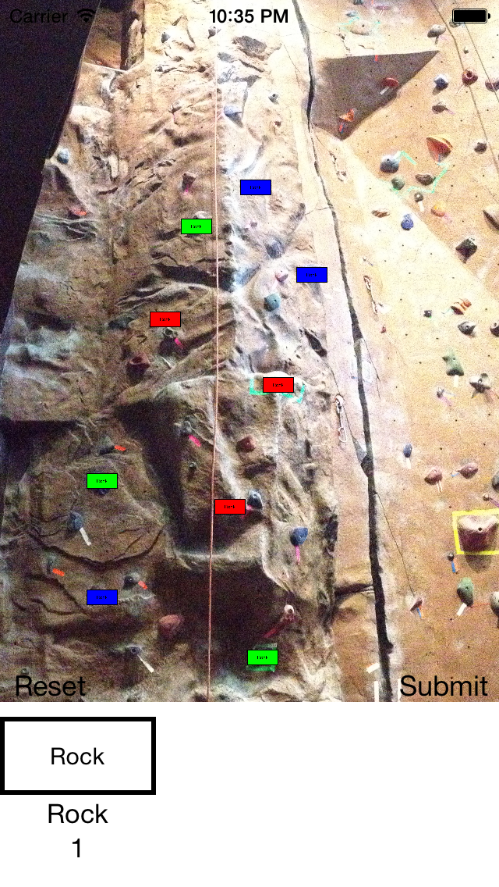

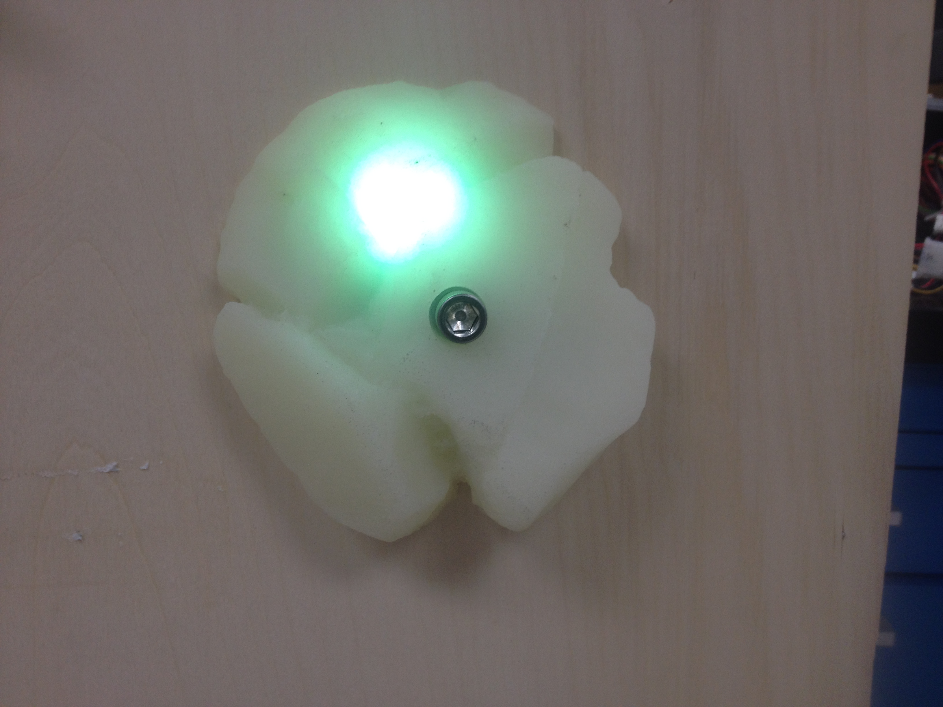

To: Professor Paul Ross Date: May 1st, 2014

From: Jacob Hanshaw

Subject: Project Firestone Final Report Cover Memo

**Cover Memo**

Through this project, I learned about several distinct aspects of the design process. Through coming up with the design, I learned about drawing initial concepts and creating an outline of a project plan. Through initial research, I learned about the current state of artificial rock walls and existing technologies such as sensors, LEDs, and microcontrollers. Through initial prototyping, I learned about common problems prototyping, the overall prototyping process, the molding process, and circuit design and layout. Through my initial business plan research, I learned about patents, how to research patents, patent law, the core tenants of planning and starting a business, and about several resources available to me. Through recording my progress, I learned to be estimate the time taken for activities, the likelihood of encountering issues, how to accurately represent the state of a design, and the importance of documenting a project. I also added to my knowledge of specific technologies such as radios and microcontrollers as well as learning new programming concepts and algorithms.

During the course of this project, I have researched technology, designed a circuit, assembled the circuit, molded holds, developed a computer vision algorithm, developed a fully-functional artificial climbing wall management application, achieved wireless transmission, developed a multi-layer networking protocol that sends information from an application to a server, to a transmitter, and to a hold.

**Abstract**

The goal of this paper is to outline the planning, development, and implementation of the Project Firestone artificial rock wall solution. The Project Firestone solution uses light up, touch sensitive rock climbing holds controlled through a mobile application to provide a more dynamic and interactive artificial rock wall experience. This results in the ability to expand artificial rock walls from poor imitations of traditional rock climbing to unique experiences in their own right.

**Executive Summary**

The Project Firestone project was conceptualized about a year ago while several of my rock-climbing friends and I lamented the unnecessary troubles and wasted potential of artificial rock walls. We found the system of placing tape to designate a route unnecessary burdensome, unintuitive, and difficult to use. We also realized that allowing the holds to react to a user’s touch would allow for new and compelling ways of interacting with the artificial rock wall.

After its ideation, the concept remained a pipe dream until the opportunity presented itself to develop the project through a senior design project and be partially funded by a company named Plexus. After deciding upon this project, we initially researched the technology and parts necessary to accomplish our original goal as well as what other patents and competition existed. After developing our initial design, we ordered the necessary parts and began construction.

We ran into a few initial design problems, but have since fixed them. We are now at the stage where we can interact with a hold wirelessly, change its color at will, notice when the hold is grabbed, and set-up walls, routes, and interesting games with the application. We still need to improve the reliability of our radio transmission and fully integrate and react to touches. Beyond these steps, we can focus on abstracting our set-up process for the user, minimizing our design’s space and power requirements, and market research, and actually starting a business.

**Table of Contents**

1 Introduction to Indoor Rock Climbing

2 Problems with Existing Artificial Rock Climbing Walls

2.1 Wastes Tape and Employee Time

2.2 Limited Interaction with Users

3 Project Firestone Solution

3.1 Solution Description

3.2 Affordances through Solution

4 Value Added

4.1 New Opportunities

4.2 Maintaining Interest

5 Initial Market Research

5.1 Similar Patents

5.2 Similar Products

6 Project Design

6.1 Initial Research

6.2 Initial Design

6.2.1 Problems

6.2.3 Solutions

6.3 Initial Prototype

6.3.1 Problems

6.3.2 Solutions

7 Project Testing

8 Business Model

8.1 Customers and Market Size

8.2 Cost analysis

8.3 Marketing and Initial Market Penetration

9 Conclusion on the Results of the Project

9.1 Overall Failures of the Project

9.2 Overall Successes of the Project

9.3 Future of the Project

10 References

Appendix A: Technical Appendix – Computer Vision Algorithm

Appendix B: Best Practice Appendix

Appendix C: Reference Products

**1. Introduction to Indoor Rock Climbing**

Indoor rock climbing is a healthy and exciting activity that is shifting in popularity as shown in Figure 1 (Ailworth, 2013). However, indoor rock climbing is currently only a poor imitator of outdoor rock climbing. It does not take advantage of opportunities unique to the medium.

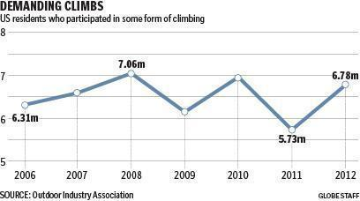

Figure 1: Rock Climbing Participants in the United States

For the uninitiated, an artificial rock wall provides a similar experience to rock climbing outdoors by bolting many pieces of rock to otherwise flat pieces of wall. Each of these pieces of rock is called a hold. Artificial rock walls add difficulty by limiting which holds a climber can use to scale the wall. A collection of holds used to scale the wall is called a route. Matching colored pieces of tape are placed near all the holds on a route to show the climber which holds they can use to complete the climb.

**2. Problems with Existing Artificial Rock Climbing Walls**

Perhaps the core flaw with modern artificial rock walls is that they only try to imitate traditional outdoor rock climbing. While artificial rock walls may offer some convenience they lack the heights, vistas, and fresh alpine air provided by traditional outdoor rock climbing. In a market fundamentally supported by outdoor enthusiasts, convenience may be sufficient during poor weather, but a stronger draw is necessary for the rest of the year. Another large portion of the market seeks exercise, but the exercise market can be especially fickle making engagement with customers all the more critical (Woolston M.S., 2014). However, traditional artificial rock walls do not provide this engagement.

**2.1 Wastes Tape and Employee Time**

Beyond this initial problem of merely mimicking outdoor rock climbing, the current system of using tape to mark out routes wastes employee time and tape. Placing every piece of tape under each hold for every route is time consuming for employees and requires blocking off the wall to users. Also, due to the energetic way the wall is used, tape peels of the wall constantly.

Beyond the set-up problems, tape is generally considered difficult to use. Even with proper understanding of how routes are marked, it is difficult to see the tape from the many angles required to climb the wall. Looking down to find a foothold that has the proper colored piece of tape is particularly frustrating. This problem is compounded as similar colors of tapes are used or tape is layered to create new colors in order to have more routes on a single wall.

**2.2 Limited Interaction with Users**

As can be expected from the system mentioned above, often the total number of routes that may be placed on a wall are limited by the colors of tape available and how many pieces of tape may be placed under a given hold. This limitation means that routes either must be circulated frequently, which may be frustrating for climbers who have not finished that route, or, as happens more frequently, the routes are not changed at all which leads to many climbers getting bored. Perhaps more problematic is that the limited number of overall routes at any given time means that the difficulty of routes may not be suitable for all members. Often times only a single route of a given difficulty is available. All together, this means that once a user completes a few routes there is little reason to come back to the gym and there is no engagement outside of the gym.

**3 Project Firestone Solution**

In order to solve this problem, a group of people uniquely suited to the task was formed. Each of the three members of this group is an avid rock climber, computer engineer, and computer scientist. One individual specialized in microcontroller development, another web development and circuit board design, and I specialized in mobile application development, software architecture, and algorithm design. Together we came up with a solution that solves these problems and provides new opportunities for gyms and hobbyists alike.

**3.1 Solution Description**

Specifically, we propose that transparent climbing holds be created with embedded multi-color LEDs and touch sensors to tell when a particular hold is in use. It is important that these holds be able to communicate wirelessly. Wireless holds allow for effortless retrofitting and for the holds be controlled remotely. Allowing the holds to be controlled gave us many affordances not available to traditional rock climbing walls. A rough initial design for our project can be seen in Figure 2 below.



Figure 2: Early Stages Project Firestone Solution Design

**3.2 Affordances through Solution**

This solution allows anyone to create their own routes, routes to be generated for a user of a certain skill level, games to be created that take advantage of the dynamic nature of the holds, and climbers to be ranked based on balance and time taken to complete a route. This also allows users create their own custom routes and monitor their progress outside of the gym resulting in greater engagement in rock climbing or with a particular gym.

**4 Value Added**

We believe this solution has market potential with rock climbing gyms as it saves gym owners the constant cost of employee time spent taping up and re-taping routes, the novelty of the product would attract new customers, and add engagement outside of the gym through its companion apps and website. This extra engagement would allow gyms to better maintain customers. We also believe that the solution has market potential with hobbyists who create their own walls as the solution saves them effort, is novel, allows them to track their progress as a climber, and allows them greater control over their rock wall.

**4.1 New Opportunities**

Simply allowing more routes is just the beginning. This system allows a climber’s progress can be monitored both in terms of balance and time taken to complete the route. This is important for those who are training, but it also helps the more casual crowd to become engaged as they can learn of their progress, create goals for themselves, and become more motivated to climb either by their own goals or through competition through means such as leaderboards or local challenges. Games could be especially enticing to casual climbers to keep them entertained and interested while getting in to the sport, though with sufficient difficulty the experienced climbers could be engaged as well through challenges they have never experienced before.

**4.2 Maintaining Interest**

It is important to note that many of the features mentioned above could be interacted with outside of the gym. A website could be created that would allow users to generate routes outside of the gym, track their progress and goals, and learn of any events or specials at the gym. This is important as maintaining habits and user interest is crucial to gyms.

**5 Initial Market Research**

Once a basic concept was formed, we looked into what other patents or products existed. This step was important in figuring out if the project was feasible as a product that a business could be built around. This step was also important as it showed us what technology was currently being used for this problem and allowed us to take inspiration from similar products. Ultimately, little was found.

**5.1 Similar Patents**

Our research into what patents existed surrounding light up and interactive rock walls was initially led astray by a misunderstanding of patent law. Initially, we thought all published patents were applicable. However, we found out through discussions with the Law and Entrepreneurship Clinic that only granted applications were applicable. This meant that the patents for climbing holds in general (Hope, 2010) or any form of lit climbing holds (Hensley, 2010), which we originally thought were going to force us to get multiple sets of licenses, did not matter. There were two patents, however, which are significant to us. A patent was published after our project began that outlines a wireless LED rock climbing hold that uses pressure-sensing technology and communicates with a computer (Horowitz, 2014). This is different from our design as our design uses vibration-sensing technology and communicates with a mobile application. Perhaps more importantly though, there is a patent that is old enough to have become public domain that outlines a rock wall that is touch sensitive and lights up, but does not use wireless technology (Kusse, 1998). We believe this patent is sufficiently detailed and is similar enough to protect us, as patent law says that a patent is be protected against improvements of technology. This means that if an unforeseen technology comes out relevant to the product then the original patent still holds. We believe that the older patent outlines everything in the newer patent except for wireless technology and computer vision algorithms. Both technologies are recent developments compared to the publishing date on the original patent, which was filed in 1994.

**5.2 Similar Products**

Overall, our search for similar consumer products did not yield anything. None of the holds we found had any sensors. We did find a skull-shaped wired light up hold, but that hold had no controller so routes could not be dynamically changed. There was also a do-it-yourself instruction guide on making a wired light-up wall, but the wall was not controlled by an application, was not cost-effective, and required a significant amount of technical knowledge to execute. The only wireless solution we found was not controlled and required 4 AAA batteries, cost $65, and was always active. None of these products offer control or interactivity, therefore, we do not believe there are competitors to this design. Links to the products mentioned above can be viewed in Appendix C.

**6 Project Design**

After conceptualizing and researching our idea it was time to bring it into reality. This means researching specific technologies, making an initial design, and building that design. Traditionally, this is an iterative process, but due to the time constraints this entire project had to be rapidly prototyped in a matter of months.

**6.1 Initial Research**

Once resolutely deciding on our basic concept, we had to start thinking about what technology to use to implement it. Our first decision was perhaps our biggest; whether or not to have the design be wireless. While a wireless design was always the goal as it allowed easy retrofitting and installation, we realized that it was not required in order to demonstrate our core concept. Ultimately, we decided on using wireless technology to push the bounds of our abilities and create prototype that was more interesting and better demonstrated our concept.

After making this decision, we had several more specific decisions to make. We needed to decide on a wireless transmission technology, a wavelength for wireless transmission, an LED, a battery, and a sensor that would indicate when a hold is touched. It was important that we found a low power solution, as we wanted to maximize the time between battery changes. In order to accomplish this we decided upon using the CC430, a well-known and documented microcontroller from Texas Instruments that is specially designed for low power wireless transmission. The microcontroller itself has a CC1101 chip built-in to allow it to read and put data on to an antenna. This then limited our frequency options to within the radio spectrum. From there, we decided on a mid-range frequency chip antenna as it had the smallest form factor, was reasonably inexpensive, and would still allow a reasonable speed of data transmission.

Beyond the wireless components and the necessary capacitors and resistors, there were three main components to decide: an LED, a battery, and a sensor that would indicate when a hold is touched. We bought many different LEDs to experiment with and we were able to find a bright LED with minimal power consumption. Finding a battery that was small, had a long lifetime, was cheap, and, ideally, was rechargeable was difficult. Traditional batteries were too large and did not have enough storage. Even batteries designed for hobby flying kits had the same problems and were even more expensive. However, we had a break through when we found the GoPro3 camcorder battery. A camcorder battery was ideal for our purposes as it is power dense, cheap due to high volume manufacturing, and very small.

Finally, we had to decide on touch sensor. Many ideas were thrown around such as measuring changes induced in capacitors through proximity to the human body, measuring the change in capacitance from parallel plates being pressed together as the hold was grabbed, using an accelerometer to sense any movement of the hold due to a pull, or using a traditional consumer available pressure sensor. These ideas were not used as they were either not sensitive enough, reliable, or, as in the case of the consumer pressure sensor, too expensive. Therefore, we ended up moving forward with two of our more creative solutions: a vibration-reading piezoelectric sensor and a light-detecting photo-resistor. The light-detecting photo-resistor operated based upon the principle that when the hold was in use the hand or foot using the hold would block the light and the change in resistance could be measured and a hold detection signal issued. However, this required all possible configurations of hold use to be accounted for with a photo-resistor at each location, could fail in low light conditions, and would read false positives due to natural changes of light or due to another part of the body, such as the chest, blocking light to the hold. The piezoelectric sensor ended up being the unexpected solution to the problem. Original fears about the sensor were that it would detect no vibrations due to the tightness of the hold to the wall or that it would detect too many vibrations from other sources such as nearby holds or impacts to the wall as a whole. However, we tested the piezoelectric sensor on an actual rock wall and were able to create a simple algorithm to differentiate wall and nearby hold grabs from actually grabs to the hold in question.

Beyond the technology, we also had to make our own rock climbing hold to house our electronics, as there aren’t semi-transparent rock climbing holds readily available. It is at this stage that we began to cast polyurethane rock climbing holds with various degrees of transparency and with added materials meant to disperse more light.

**6.2 Initial Design**

After deciding on our components we needed to design the circuit to allow them to communicate. This was done predominantly through the use of Texas Instruments’ reference designs. We implemented the parts of their designs necessary to use their components, added our own, and fit it all on a circuit only a couple of square inches in size. Most components actually come in different sizes based upon the need of the consumer. We used the smallest size of components readily available. The schematics of our design can be seen below in Figures 3-5.



Figure 3: Microcontroller Schematic

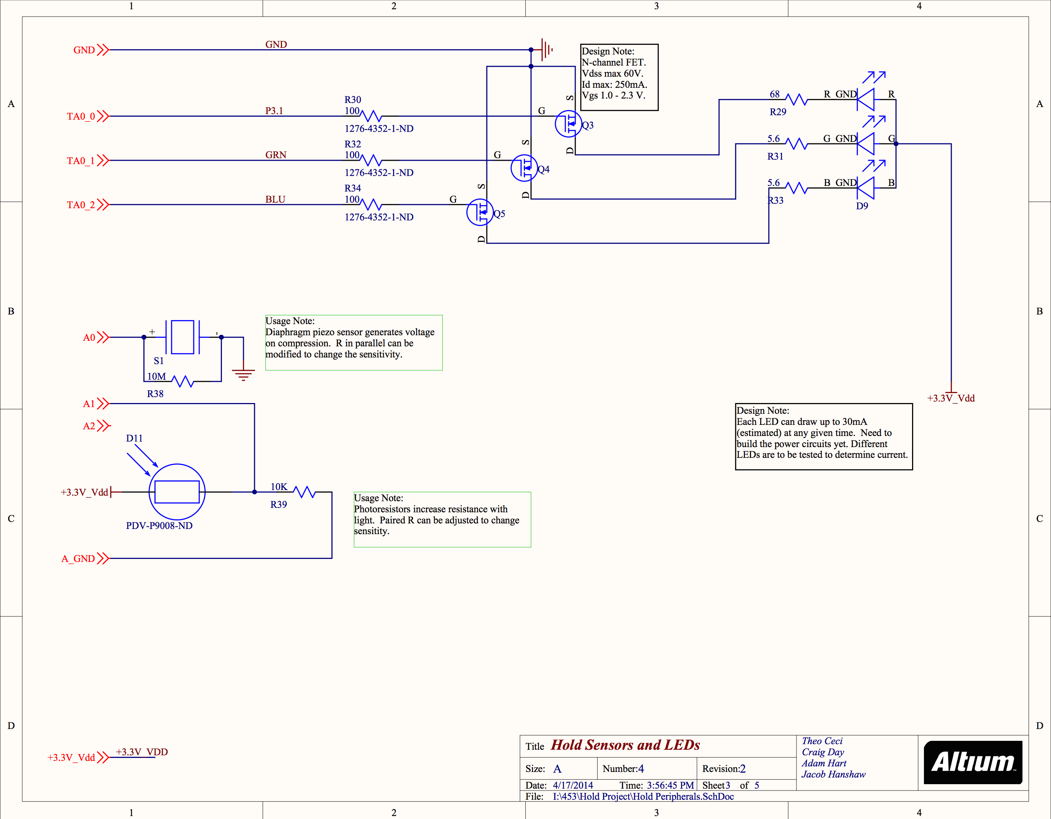

Figure 4: LEDs and Sensors Peripherals Schematic

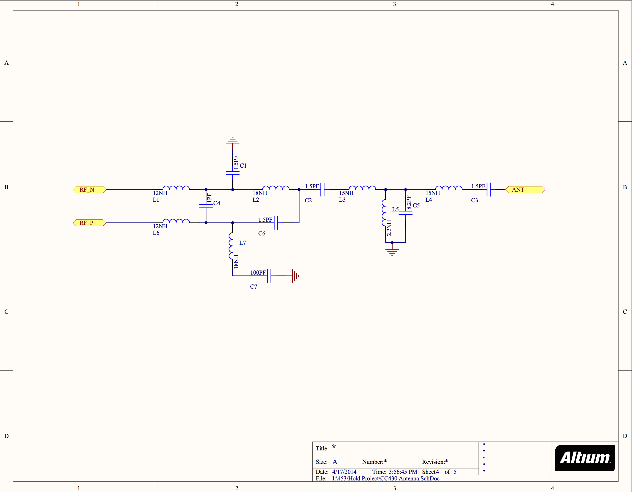

Figure 5: Antenna Schematic

**6.3 Initial Prototype**

After we designed and ordered our circuit boards, it was time to build them. This process seemed to go well. We tested incrementally as we built our boards and found that our power circuit was behaving as expected. We then added our microcontroller and LED, but were unable to program our board. This could be due to many different issues and we spent a significant amount of time trying to find the problem. At last, we noticed that the microcontrollers pin labels were the mirror version of what they were supposed to be as the microcontroller documentation had been read incorrectly. This problem meant that we had to purchase a new set of circuit boards and wait for them to arrive.

While waiting for those circuit boards, we used microcontroller radio test kits to prepare wireless communication code for when our boards did arrive. This seemed to allow us to continue work while waiting for hardware and to be better prepared to finish the project when the boards arrived. We also started making a new revision of our semi-transparent rock climbing holds as we had found a cheaper polyurethane supplier and we realized our holds needed to be larger to accommodate our boards and battery.

During this entire process, we also developed a mobile application that could communicate to our holds through custom drivers on our Zedboard base station. The mobile application controlled the state of the holds and allowed users to set-up a wall, create a route, pick an existing route, or play games. A screenshot of the mobile application can be seen in Figure 6 below.



Figure 6: Mobile Application Screenshot

**7 Project Testing**

Even after getting our second revision of circuit boards back and assembling them we still ran into many problems. Initially the boards still would not program due to soldering problems, we found out the code we made on the radio test kits would not work due to design differences, our radio communication was a bit spotty, and our algorithm for the piezoelectric sensor did not translate well on to the new hardware. We also had problems with boards not programming at all still, wires ripping, poor battery connections, and batteries not being well charged. Ultimately, all these problems are fixable through a little more work and care in assembly, but we were not able to fix these problems in time for our demonstration. The final board can be seen in Figure 7 below.



Figure 7: Finished Circuit Board

**8 Business Model**

One of the most interesting things about our project was that it solved a real problem in an innovative way that opened doors to new possibilities. We always knew that this product had market potential and we designed it with this in mind. Throughout the design process we considered the cost, reliability, and maintenance of our design and we started to research the business and gather resources early on. We also met with the Law and Entrepreneurship Clinic on campus, which helped us think about how to start a business and about patent law.

**8.1 Customers and Market Size**

Our customer base would be hobbyists that own their own small rock climbing walls and rock climbing gym owners. Numbers on the size of the hobbyist market are difficult to come by, but a small time hold manufacturer cited sales of $400,000 (Yara, 2012). As far as gyms are concerned there were 450 rock climbing gyms last year in the United States alone and that number is likely to grow (Barry, 2013). Gyms vary in size with anywhere from around 5 walls in a general athletic facility to 25-75 wall in gyms focused on exclusively rock climbing. Each wall contains around 100 holds for a total of around 5,000 holds per gym and roughly 2,250,000 climbing holds in the U.S. However, this number is very rough approximation based upon my experience with rock climbing gyms thus far.

**8.2 Cost analysis**

Throughout the research and prototyping process we considered the per hold cost. We picked all our components with cost in mind and that ended up making the holds relatively cheap. Our prototype holds cost us roughly $25 a piece. This price will decrease dramatically through a higher volume of manufacturing, as all the parts we used are available in bulk and are significantly cheaper when bought in bulk. Current hold prices range from $10-50 for an average size hold to as much as $850 for a large hold. As mentioned earlier, the closest commercial competitor that sold non-controllable holds with built in LEDs sold them for $65. These prices can be viewed in through the links in the Appendix C climbing holds and similar products section, respectively. We believe that after accounting for the cost of the contracting out our manufacturing process, we still should be able to sell the holds at around $50 with about a 50% profit margin.

**8.3 Marketing and Initial Market Penetration**

Despite our firm belief in the quality and potential of our product, lack of competition, and early accolades, we realize that we must first validate our market. We also realize that even with a functioning prototype gyms may be hesitant to pay for a new product without a proven track record. To that end, we plan on creating a complete prototype set and requesting that it be featured at a local rock climbing wall. We will then be able to gather user testimonials and statistics to validate our design. Once this is accomplished, we believe contacting gyms directly and advertising through rock climbing wall manufacturers and magazines will lead to a successful enterprise.

**9 Conclusion on Results of the Project**

Through this project we have learned about molding rock climbing holds, designing circuit boards, hardware debugging, a variety of sensors, radio communication, radio antennas, reading datasheets, microcontroller programming, computer vision, patents, the artificial rock wall business, and starting a business. This project could be considered a success as a class project from that information alone. However, we wanted it to be a successful project in its own right and the extent to which that was accomplished is a little less straightforward.

**9.1 Overall Failures of the Project**

Despite our best efforts, we ran in to quite a few problems. The biggest of which was that our circuit board layout had our microcontroller backwards. Human errors in a complex design without significant prior experience are expected, but this error set us back several weeks due to the time taken to design, manufacture, and ship new boards. This was compounded by the fact that we attempted to write code on a similar platform to port to our new boards later, but we found out that the code was incompatible. Our lack of time coding the boards meant the code we produced wasn’t as well made. This potentially combined with slight problems with the hardware meant that our radio communications were not always successfully transmitted, the hold would get stuck in a bizarre state, timing routes was not fully completed, and the algorithm to filter out proper hold touches was not completely finished. We were also unable to make the raw number of holds we wanted to as we were planning on building more holds once the software was complete. These two facts combined severely hampered what could have otherwise been an impressive project.

**9.2 Overall Successes of the Project**

It must be noted that despite the problems associated with running out of time on the project, the project was still well received and tied for runner-up for the best project in our electrical and computer engineering senior design class. The mobile application I designed performed well and was visually pleasing and intuitive. Despite an intermittent loss of signal, we could easily control our holds from the mobile application. The holds would light up when grabbed as well. We showed this off in the demo as either the hold would flash if it was grabbed and it was off route or it would stay lit as part of our Add On game mode. The holds themselves were also lit pretty well, but depending on which of our test molds was used the color could not be seen from all angles. The finished hold can be seen in Figure 8 below.



Figure 8: Finished Climbing Hold

**9.3 Future of the Project**

Overall, a significant amount of work was done to bring what was once an optimistic dream into reality. However, there is still much work to be done. In addition to the previously mentioned minor fixes and tweaks to our current device, we hope to optimize our device. Currently, the board and battery are too big to fit into some of the tinier holds. We hope to fix that with flexible PCB boards and the elimination of some of our components that were used for testing. We also plan to create new hold materials to better disperse the light created by our LED and to make our board more efficient to lengthen its battery life. However, even without these optimizations, we feel that we have created a successful product that, with minor polishing and a bit of branding, could take the climbing world by storm.

**10 References**

Ailworth, E. (2013, August 8). - The Boston Globe. *BostonGlobe.com*. Retrieved April 30, 2014,

from http://www.bostonglobe.com/business/2013/08/07/number-popularity-rock-gyms-climbing/JUikUNxTvyA6YGLUqco17I/story.html

Barry, E. (2013, November 20). Power Pitch. Yahoo Finance. Retrieved April 1, 2014,

from http://finance.yahoo.com/blogs/power-pitch/turning-rock-climbing-hobby-millions-125132801.html

Hensley, J. (2010, January 7). Patent US20100004098 - Illuminated rock-climbing

hold. *Google Books*. Retrieved May 2, 2014, from https://www.google.com/patents/US20100004098?sa=X&ei=2ElkU7jwHIOmyASvtYKQDw&ved=0CDcQ6AEwAA

Horowitz, M. B., Damle, A. S., & VanKempen, M. G. (2014, March 11). Patent

US8668626 - Wireless pressure sensing rock climbing handhold and dynamic method of customized routing.*Google Books*. Retrieved May 5, 2014, from https://www.google.com/patents/US8668626?hl=en&sa=X&ei=7f85U_2hHKTr2QWq4IGoBw&ved=0CEcQ6AEwAg

Kusse, B. R., & Strickler, J. H. (1998, March 31). Patent US5732954 - Route recording,

marking, and scoring apparatus for sport climbing walls.Google Books. Retrieved May 5, 2014, from https://www.google.com/patents/US5732954?hl=en&sa=X&ei=RfA6U_DULqqqyAGwpoGAAg&ved=0CGwQ6AEwBw

Hope, D. (2010, November 18). Patent WO2010132865A1 - Climbing holds.*Google*

*Books*. Retrieved May 2, 2014, from https://www.google.com/patents/WO2010132865A1?cl=en&dq=rock+climbing+hold&hl=en&sa=X&ei=70lkU9qXNsy2yAS6goCYDg&ved=0CEMQ6AEwAg

Woolston M.S., Chris. (2014, March 11). Climbing Gyms. *Climbing Gyms*. Retrieved

May 1, 2014, from http://consumer.healthday.com/encyclopedia/exercise-and-fitness-18/misc-health-news-265/climbing-gyms-647124.html

Yara, G. (2012, August 2). Tempe maker of rock-climbing holds turns hobby into

livelihood. azcentral.com. Retrieved April 1, 2014, from http://www.azcentral.com/business/articles/20120802tempe-rock-climbing-holds-maker-hobby-livelihood.html

**Appendix A: Technical Appendix – Computer Vision Algorithm**

In this projects infancy, I had a very different idea as to how we would locate our holds physically on the rock climbing wall. This step is crucial as the holds have no way of knowing where they are in physical space and we must know the position of the holds in order to address them individually, construct routes, or make games. Currently, we are allowing the user to manually position hold icons on the wall. The user can know they are positioning a certain hold, as tapping the hold will change its color. Once they position all the holds then that wall may be saved and referenced further.

However, originally I wanted to automate this process through computer vision. The idea being that we could use the same general theory of how a human would position the hold icons on the virtual rock wall to get relative positions of the rock climbing holds. The user would position the mobile application to view as much of the rock wall as possible. The application would then change all the holds colors at once giving them each a unique pattern to display. E.g., a certain hold would be sent the pattern to flash of green, yellow, red, green and the application would notice the position within the camera’s view that changed colors according to that pattern and therefore know that holds relative position. If the entire wall could not fit within the view of the camera at a time, then multiple observations could be recorded and stitched together.

This process may seem straightforward to a human observer, however, computer vision is traditionally one of the hardest areas of computer science. Discerning the boundary between objects specifically is very difficult as the camera used does not have depth information and our brain relies on a complicated knowledge base to discern objects. The problem is made more problem by the fact that the mobile device is being held by a person who shakes and fatigues. Therefore, the processing must be done as quickly as possible to reduce fatigue and shakes must be corrected for by keeping relative positions and trying to find multiple visually unique points to keep as reference. The fatigue problem is also why all holds are flashed unique patterns at once instead of each hold being turned on in turn; though turning each hold on in turn would arguably be a simpler problem.

For the reasons above and for personal satisfaction, I began considering the fastest way to locate arbitrarily shaped objects of a certain color. There are several ways to do this such as hierarchical clustering, attempting k-means with additional criteria to eliminate outliers, or a variety of other methods which were eliminated as these methods make many passes through all of the pixels which is already a large data set. The ideal algorithm would do minimum calculations and find arbitrary objects of a certain color within a single pass. To this end, I began drafting my own algorithm.

I ended up creating a method of doing so that works as follows. The algorithm searches for patches of a specific set of colors. For example, the algorithm may look for patches that are roughly blue, red, green, or yellow. The algorithm tracks patches by creating temporary hold objects that contain the color, the minimum row, minimum column, maximum row, maximum column, last minimum column, and last maximum column. The min and max, row and column values are used to find the center of the hold while the last column values are the values from the previous row seen in the algorithm and they are used to see when a hold has been finished.

The algorithm works by taking input a row at a time. It tracks continuous patches of color. This is a crucial distinction. A temporary hold is active if its color is found within the range that it has been found in previous rows. Otherwise, if one of the specified colors is found outside the range of any of the active holds a new hold is created. It tracks a list of active holds that are sorted based upon their minimum column value, the minimum column at which there color appeared. If a pixel is found that is within the acceptable color spectrum for one of the colors and it is not within the range of the active list of holds then a temporary hold is created. This hold remains active across the row of readings until a pixel is found that is not of its color. At this point, the algorithm checks if the hold that has just become inactive has overlapped with other temporary holds of the same color. If this is the case, then it combines those holds. A hold is removed form the active list and considered finished, if a pixel of its color is not found between its last minimum and maximum column value of the current row. At this point, the approximate center of the hold can be calculated to be midway between its minimum and maximum, row and column values. I have implemented this algorithm and it is able to run with a live camera feed. Meaning the algorithm runs so quickly that I may mark the points where I believe holds to be overtop the live camera feed of the device.

This process gives the current positions of color patches that could be holds. The final step which I have not actually implemented would be to keep a list of potential hold locations and combine locations from frame to frame that are short distances from each other likely due to shaking hands or slight light variations. When locations are combined from frame to frame the colors are different then the current color is added to the ordered list of previous colors. The application knows the unique pattern of colors it sent to the holds and, therefore, from the unique pattern of colors, we know which signal controls which hold. Finally, a picture is taken along with the hold locations so that hold icons may be placed on the picture and the holds may be controlled through their icons through the user interface.

However, there are a few flaws with this system. Being on the ground and looking at the wall may make some holds difficult to see, though this is not a big problem as the same holds would be difficult to see to anyone on the ground. However, more orthogonal viewpoints of the wall will likely require a ladder. Also, it is unlikely, but in cramped quarters there may not be a spot where the lens can capture the whole wall even with stitching. I see the above problems as rare and minor inconveniences. The biggest problem in theory is that each time a hold is replaced on the wall it requires starting the process over as opposed to a user simply dragging a new hold on or off the virtual wall as in our current system. The other problem is that our equipment currently is not reliable enough. We have packet losses, so a hold will likely not go through all of its designated colors and the algorithm cannot produce a valid result without valid input. Though I see this as an opportunity to use the algorithm, as we can send packets to a single hold, look for a change to the camera’s view, and if the wrong change occurs or the change does not occur then we know that there is a problem. In this way we can automate the testing of our rock wall and save ourselves a significant amount of time.

**Appendix B: Best Practice Appendix**

Running a business and selling a product comes with a laundry list of best practices. There are traditional, well respected, and legally enforced best practices to prevent discrimination and ensure that products are safe to use. There are also common best practices such as fair treatment and payment of all employees. Most of these best practices affect all businesses and are well known. Therefore I will focus on the best practices that specifically affect the Project Firestone product and business, should it ever become a full-fledged business.

First, I will talk about the Project Firestone product. The Project Firestone product has to deal with its own safety concerns as many other products do. However, the Project Firestone product is a bit unique in that it is a recreational product that typically comes without warning labels and is used in a slightly dangerous environment. The users are generally expected to understand the risks involved with rock climbing and gyms will likely have insurance protecting themselves should an injury take place. All users are expected to take necessary safety procedures such as wearing a harness and clipping in to a belay line in order to prevent injury. These procedures should prevent most, if not all, injuries that could be associated with a climbing hold. However, there is an expectation that the climbing holds do not break or even twist during use. While a person climbing without the proper safety precautions could be considered reckless, the person could still claim their athletic abilities were sufficient and that they would not have fallen had the hold not moved in any way. A person could also be injured if a piece of a broken climbing hold fell and hit them. This is also unlikely to traditional holds being small in size and relatively light, but bigger holds do exist and all eventualities should be prepared for.

Fortunately, this safety concern is relatively easy to account for. First, warnings can be made about the need to properly tighten down or otherwise secure rock climbing holds to the wall. Secondly, the holds can be tested to withstand great strains with a safety margin beyond the worst case that could be seen in an actual environment. It is our responsibility to perform these tests and ensure that we make a safe and quality product even at the expense of profits. This notion of quality indeed extends beyond merely what is safe. A business must consider their standards for best practice in terms of quality components as well. It may be cheaper to buy Chinese knockoff batteries, but these may come at the expense of the original creator and the lifetime of the batteries may be shorter. Being excessively cheap on project components can be considered a form of deception and may work in short term, but fail long term as customers realize the shoddiness of the product.

Secondly, I will talk about the Project Firestone business. The Project Firestone business is unique in terms of the freedoms of the founders and the types of activities that may be considered payable. For example, a trip to a rock climbing gym in Hawaii may be considered acceptable if it is part of a sales trip or a trip to a rock climbing competition or exposition may be considered acceptable if it helps us learn about the customers or competition. However, there is a grey line here between pleasant work or play and embezzlement. One has a responsibility to the company, coworkers, and investors, if they exist, to accurately document work related expenditures and work time.

There are, of course, many other considerations when it comes to best practice for a business or for an engineer. Best practices are a complicated issue and I have only considered a few specific to Project Firestone here. However, the core principles remain the same. Think foremost always about the customers’ safety and health, be honest about products and services, and treat both customers and employees with fairness and respect.

**Appendix C: Reference Products**

Similar Products

<http://rockymountainclimbinggear.com/shop/l-e-d-climbing-holds-3-skulls/>

<http://www.instructables.com/id/LED-Climbing-Holds/>

<http://rockymountainclimbinggear.com/shop/l-e-d-climbing-holds-25-bolt-on/>

Climbing Holds

<http://www.dpmclimbing.com/climbing-gear/view/climbing-hold-review>

<http://www.gearcoop.com/So-iLL-Immunity-Climbing-Holds/dp/B00CD8QF1K?traffic_src=froogle&utm_medium=organic&utm_source=froogle&gclid=CJ-ps6jbmr4CFeY-MgodGlUAyg>

<http://www.teknikhandholds.com/site/index.php?r=order>

<http://www.threeballclimbing.com/climbing_holds/limestone_47.htm>

**Presentations Review**

During this project, I made two presentations. One was a proposal for what I would like to research and the second was the results of my research. These presentations were differentiated further by the style of presentation. The first was a shorter presentation, about five minutes in length, without a powerpoint and the second was a longer presentation, about 8 minutes in length, with a powerpoint. By watching recordings of these presentations I was also able to notice behavioral difference between the two presentations as well.

During the first presentation, I seemed very uncomfortable at the beginning of my speech. This can be observed form the way I tilted my head back, overly gesticulated, and spoke too quickly. The lack of a powerpoint forced me to better prepare myself for the speech and this knowledge is noticeable in a decreased number of ums and nonsense words as well as in my focus and overall demeanor. However, there are several points where I obviously pause in order to recall some facts about my project. This made me seem slightly less prepared compared to simply glancing at a powerpoint in order to regain my train of thought. Another interesting observation was that after I picked up a prop to show the audience, I seemed to relax slightly. The prop engaged the audience, reduced the amount of gesticulation, and caused me to look at the audience more rather than just looking at the camera. I also noticed that I became more relaxed as the presentation continued.

During the second presentation, I seemed relatively calm in the beginning of the presentation though I still noticed that I seemed to relax more as the presentation continued. Having the presentation slides behind me ended up being a mixed bag of pros and cons. It seemed like I spent a fair amount of time looking behind me at the slides, but I also spent more time slowly and directly looking through the entire audience, removed excessive gesticulation for the most part, and I did not talk too quickly or otherwise rush the presentation as much as I did in the first presentation. This may be due to extra confidence coming from having the slides behind me for reference. However, having the slides as a safety net caused me to spend less time preparing. Also, I noticed myself looking at the slides even when I knew what I was going to talk about next.

Overall, I learned several things from the two presentations. The first is about how much unnecessary backwards head tilt I have when I’m not comfortable and generally how noticeable it is when I’m less confident in my presentation. I had not noticed this particular quirk during presentations and it was only through the videos I noticed it. The second is how I become more comfortable and confident as the presentation continues. This could be due to a certain flow reach and adjustment to the situation on my part. I feel that it is likely that if I spend a few moments to calm myself before starting a presentation that my future presentations will go more smoothly. I also realized the utility of having props during a speech. I initially valued them only as visual interest for the audience, but I now realize that they help temporarily take the focus off the presenter and allow the presenter to relax. Finally, perhaps the most important things I learned was to prepare for all presentations as if I did not have a slideshow. Things could go wrong with electrical equipment forcing me not to use the powerpoint and it would be wise to prepare for such eventualities, but I see a larger impact in the level of increased preparedness I had when I did not use a powerpoint. From the two presentations, it seemed like I felt the most comfortable towards the end of my first presentation after I became accustomed to the environment and confident that I had sufficient knowledge and recall to present the rest of my presentation smoothly.